COURSE : CLOUD COMPUTING LAB
INSTRUCTOR : SIR MUHAMMAD SHOAIB

SUBMITTED BY : FATIMA KASHIF
REG# 2023-BSE-018
DATED : OCTOBER 10, 2025

LAB TASKS

Install Git on laptop

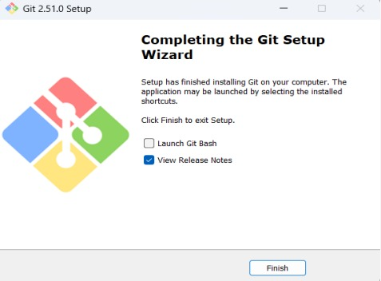

Task #01
Create a new private repository named Lab2 on GitHub.

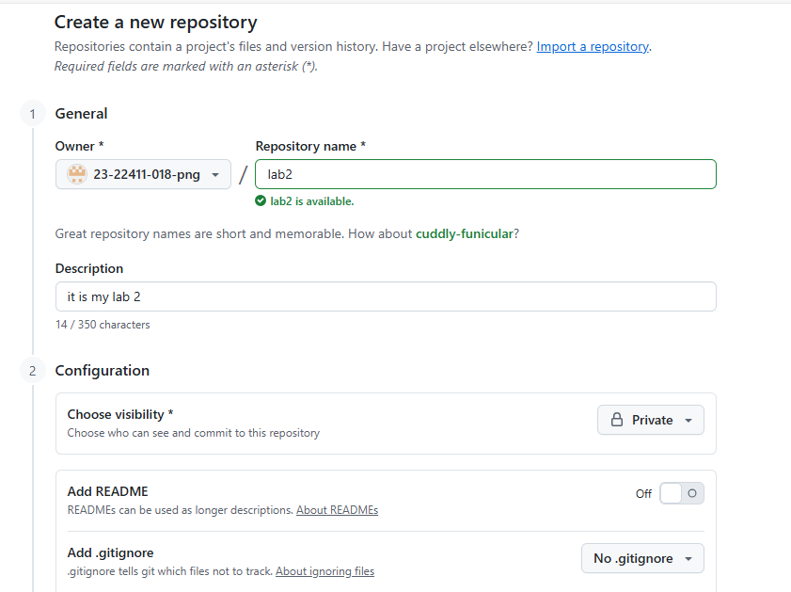

Clone lab2 repo

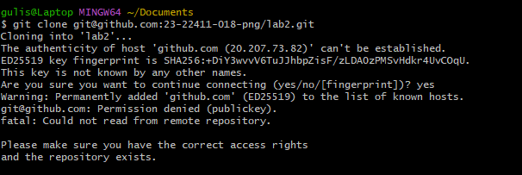

Take a screenshot of your repo settings showing it's private. Save as repo_private.png in your Lab2 repo.
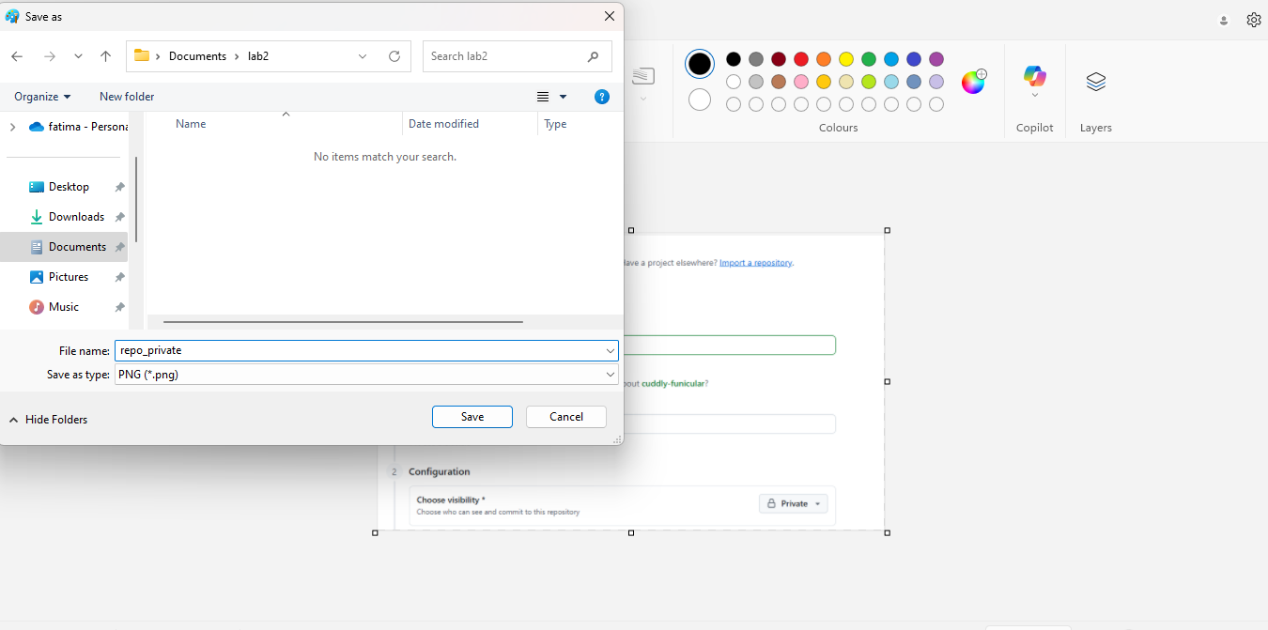

TASK # 02
Generate a new SSH key using PowerShell
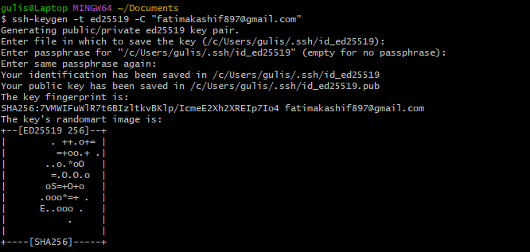
Add your SSH public key to GitHub (Settings > SSH and GPG keys).Take a screenshot of the added key as github_sshkey.png
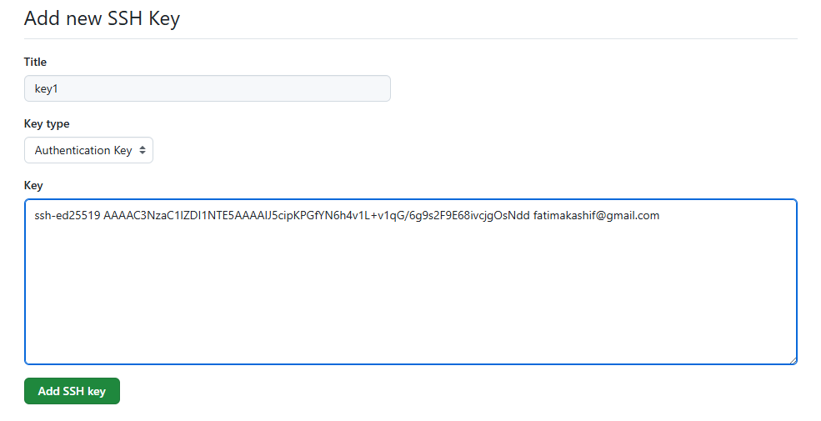
.Clone your Lab2 repo using SSH
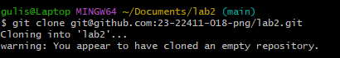
TASK#03
Set up your Git identity (this ensures all commits are linked to you)
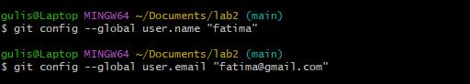
Verify your configuration:
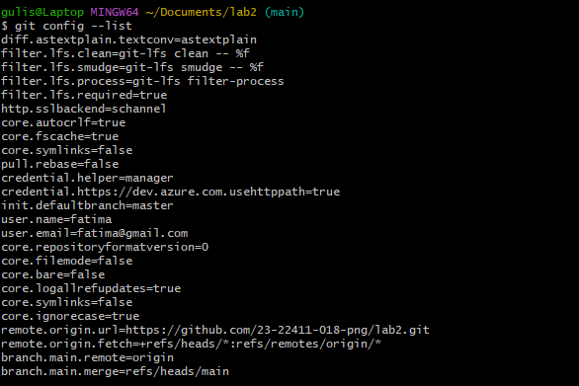
TASK # 04
Navigate into your cloned repository folder.
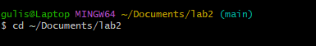
Show hidden files and locate the .git directory.
Explore whats inside

TASK#05
Delete the existing .git folder from your cloned repo using Git Bash
Re-initialize the local git repository
Add a file named README.md and commit it
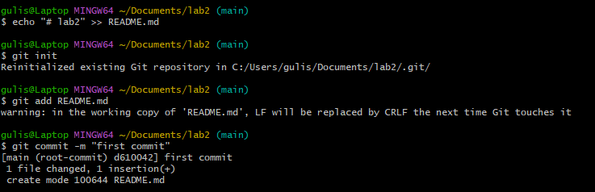
Connect local repo to Github and push
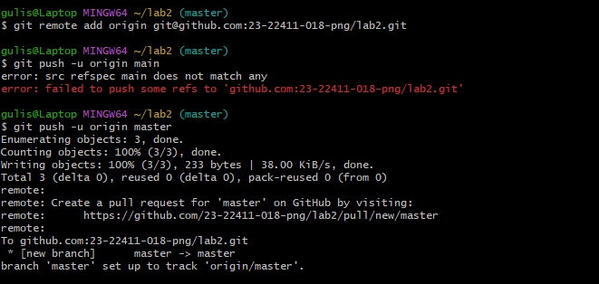
TASK # 06
Create a new file notes.txt and write a note.
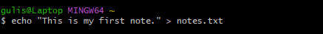
Check status. Save screenshot as status1.png.
Stage and commit. Save screenshot as commit_notes.png.
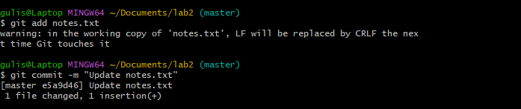
Edit notes.txt and repeat status/commit steps.
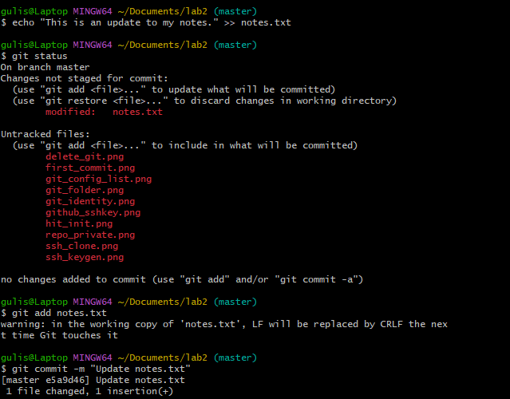
TASK # 07
On GitHub (web interface), create a branch named bugfix/user-auth-error.
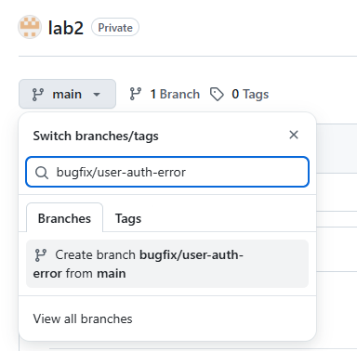
Pull the branch to your local repository to sync.
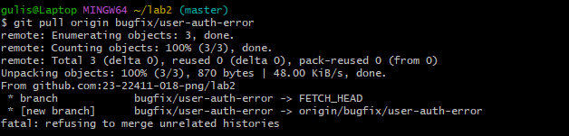
TASK # 08
Create a branch named feature/db-connection using Git Bash.Push the branch to the remote repository.
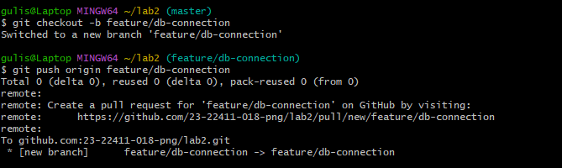
TASK # 09
Create and switch to a branch feature-1
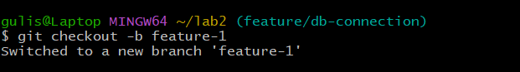
Modify main.py (add a function) and commit
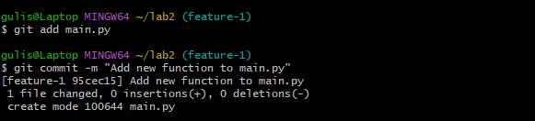
Switch back to main and merge
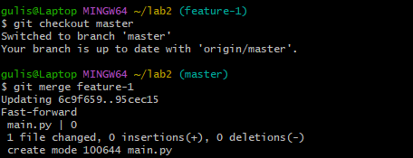
Push all branches
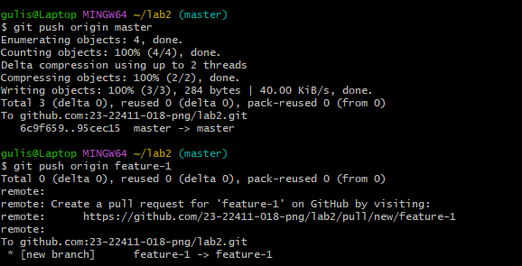
TASK # 12
Create the following branches to simulate a professional branching strategy
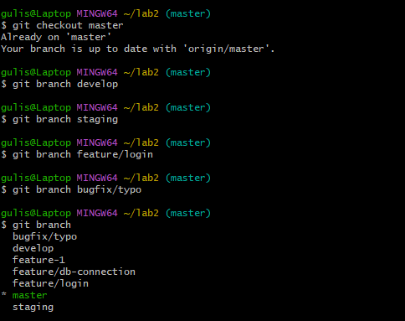
Documentation with Screenshots

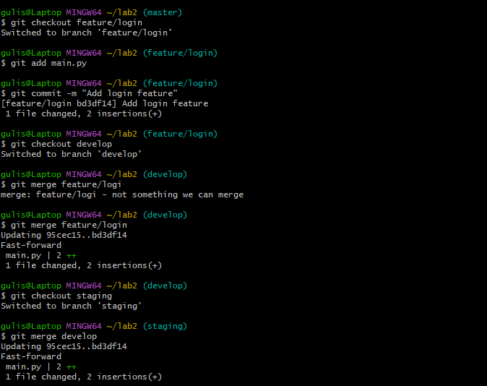
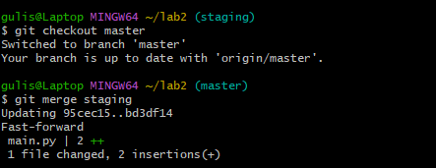
TASK # 13
Delete Remote Branch After Merge
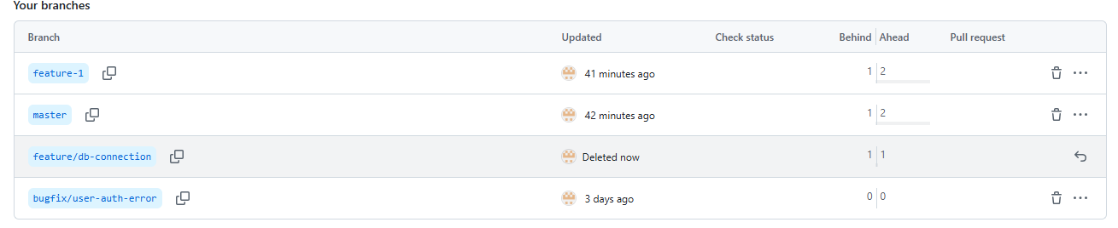
Update Local Repository
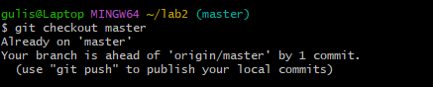
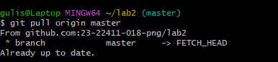
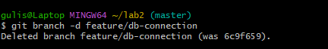
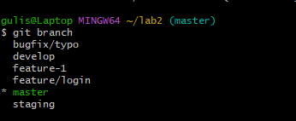
My lab2 document
